Jarron Bailey

Homework 3

Input Card num = 4388576018402626 | Prefix = 43

Results = Not a valid number | Prefix = True

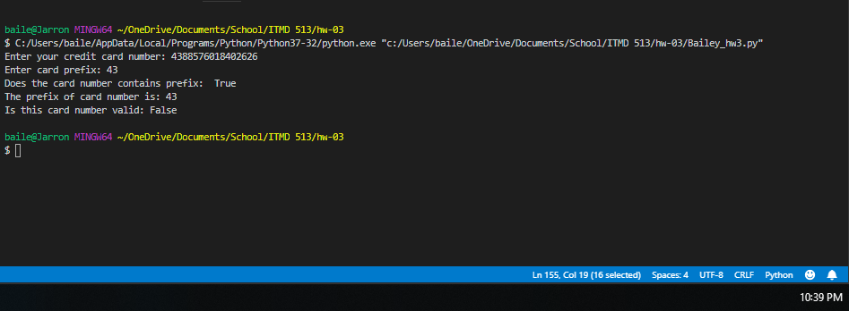

Input Card num = 4388576018402626 | Prefix = 20

Results = Not a valid number | Prefix = False

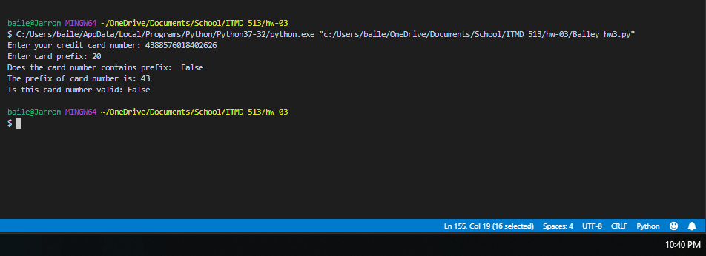

Input Card num = 4388576018402626 | Prefix = 20

Results = Valid number |Prefix = False

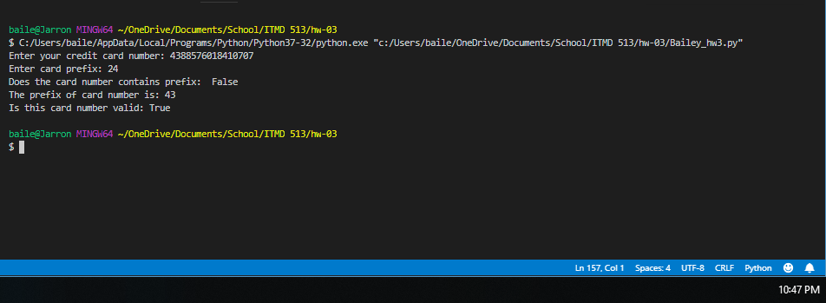

Input Card num = 4388576018410707| Prefix = 43

Results = Valid number |Prefix = True

